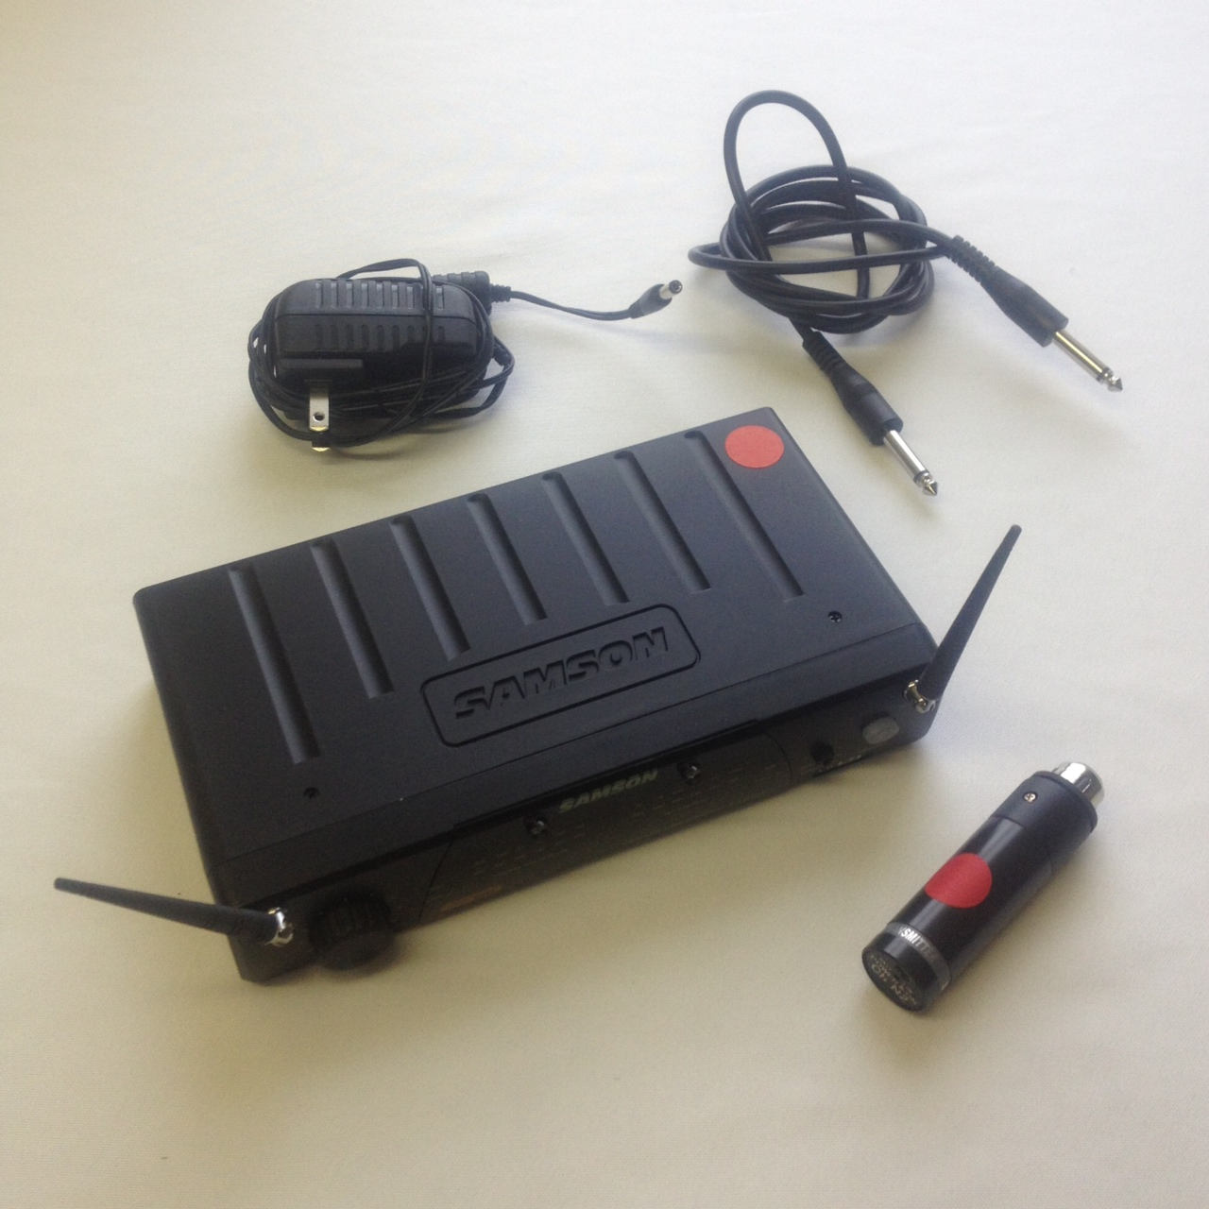

WIRELESS MICROPHONE SYSTEM

GETTING STARTED:

You may have noticed that there isn’t a microphone in your kit. This kit is intended to be used with our other PA system packages that already include a microphone. This kit essentially has two components: The handheld microphone transmitter and the receiver. Use the included power adapter to plug the receiver into a power source. Now use the included ¼ inch cable to connect the receiver to the PA system (see PA instructions for more info). Now take the microphone transmitter and plug it into the microphone that’s included in your PA system. Make sure the power switch on the transmitter is set to “OFF” for now. Turn the volume knob on the receiver all the way down and turn the power on using the power button on the front of the unit. Now flip the power switch on the transmitter to “ON” and slowly raise the volume knob until you’ve reached the desired volume level.

When you are done using this wireless system, flip ALL switches off BEFORE disconnecting all components.

EQUIPMENT FAILURE:
You agree to immediately discontinue the use of rented items should it at any time become unsafe or in a state of disrepair, and will immediately (one hour or less) notify Are You Ready to Party of the facts. Are You Ready to Party agrees at our discretion to make the items operable within a reasonable time, or provide a like item if available, or make a like item available at another time, or adjust rental charges. The provision does not relieve renter from obligations of contract. In all events, Are You Ready to Party shall not be responsible for injury or damage resulting from failure or defect of rented items. If you have any questions about this, ask an employee at Are You Ready to Party or refer to Section 3 of your lease agreement’s terms and conditions. 207-873-4944

