Are You Ready to Party??
4 Sanger Ave. Waterville, ME 04901 207-873-4944

DIRECTIONS FOR SNO KONE MACHINE

Machine Description:
The Sno Kone machine is automatic shaver with a tremendous capacity. You will find that it keeps up with any demand. It consists of the hopper, which houses the cutter head, the pusher handle, the motor, and the display case. It operates on 120 Volt, 15 Amp, single phase, 60 cycle AC current. The Sno Kone machine can take ice cubes or block ice, if you break the block into pieces approximately 3 to 4 inches in size.

MACHINE OPERATION

- Fill the hopper to within an inch of the top with ice cubes or block ice (no larger than 3 to 4 inches). The larger the pieces, the better the snow.
- Switch the motor on. Wait for the motor to come to full speed (a minute or so).
- Push the pusher handle down against the ice in the hopper. Apply firm and even pressure to make the best snow. Practice will allow you to gauge when to stop pressing. This allows the ice to resettle against the shaver head. You may find that you need to relieve the pressure two or three times in a cycle. Too much pressure will result in snow that is coarse, and too little pressure will make the snow too fine.

Never allow any foreign or metallic objects around the shaver area of the Sno Kone machine. Ice picks, scoops, and debris that may be in the ice often damage the blades. Never under any circumstances put your hands or fingers near the shaver at any time.

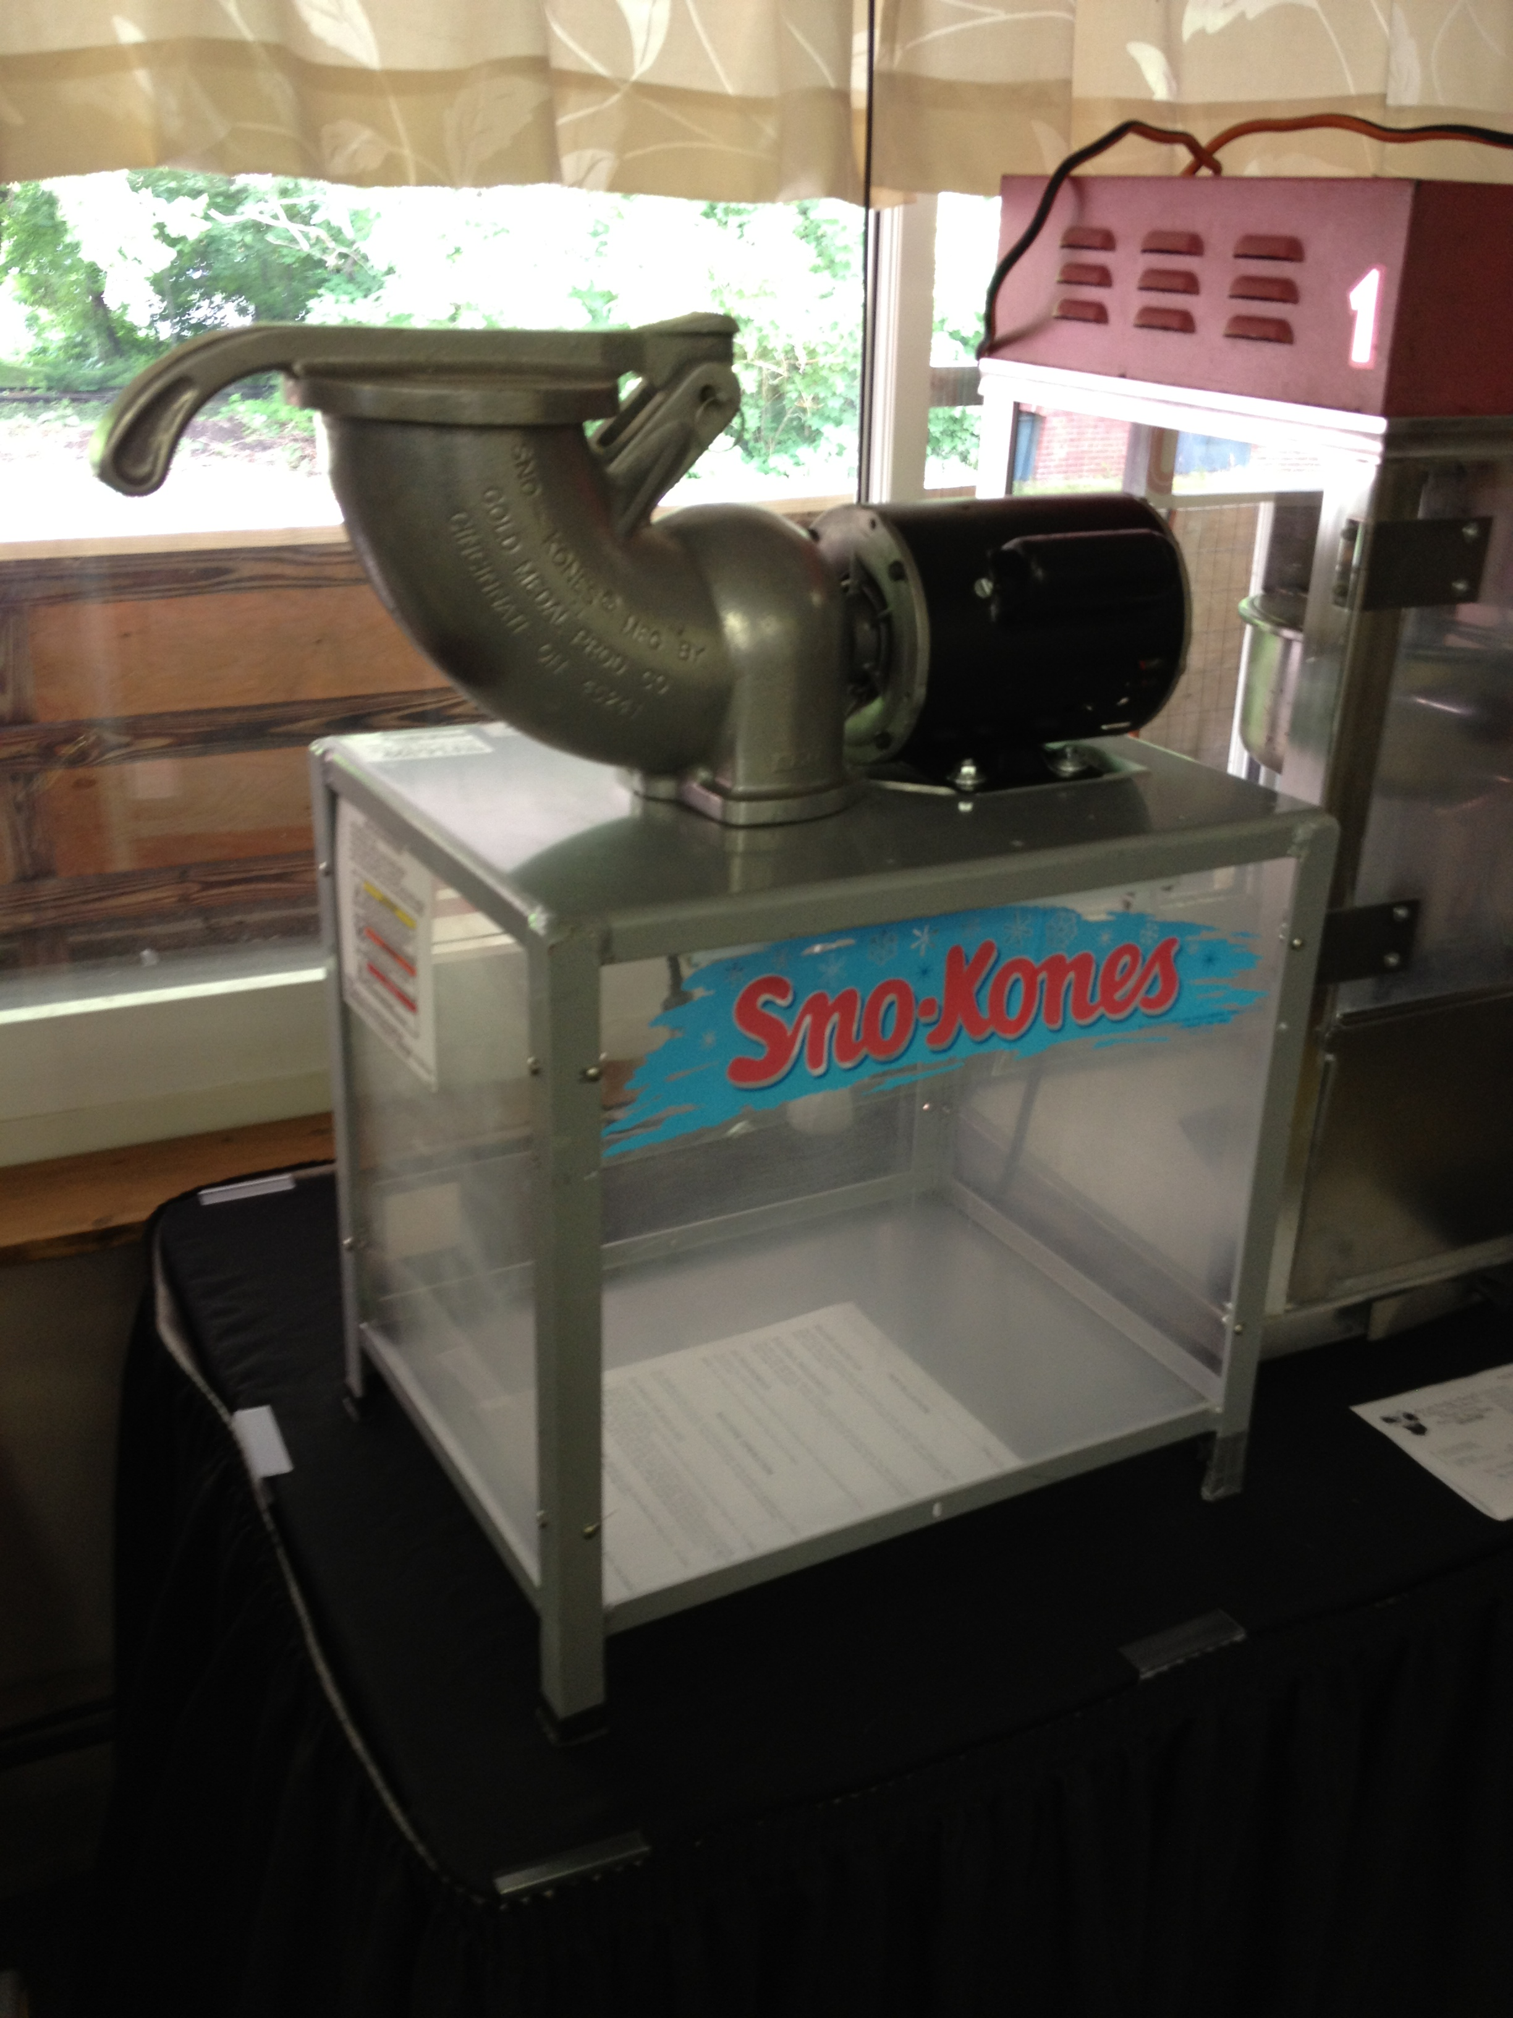

EQUIPMENT FAILURE:
You agree to immediately discontinue the use of rented items should it at any time become unsafe or in a state of disrepair, and will immediately (one hour or less) notify Are You Ready to Party of the facts. Are You Ready to Party agrees at our discretion to make the items operable within a reasonable time, or provide a like item if available, or make a like item available at another time, or adjust rental charges. The provision does not relieve renter from obligations of contract. In all events, Are You Ready to Party shall not be responsible for injury or damage resulting from failure or defect of rented items. If you have any questions about this, ask an employee at Are You Ready to Party or refer to Section 3 of your lease agreement’s terms and conditions. 207-873-4944

